Advanced Government /25 Name_______________________
Chapter 4: True/False Review Questions ½ POINT EACH
Mr. Faulhaber

TRUE/FALSE: Determine the validity of each statement and mark accordingly by placing a T or an F in the space provided AND CIRCLING T or F.
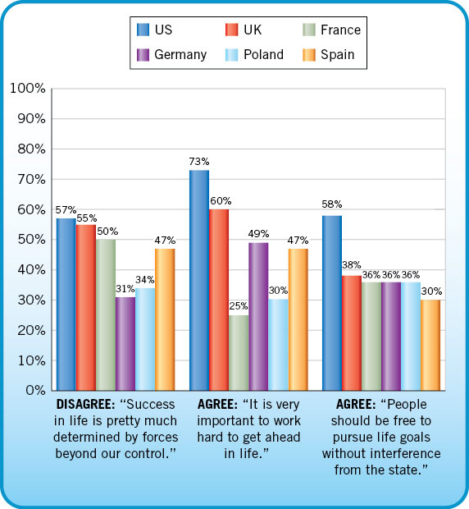
_____1. T/F Americans are more likely than citizens of other countries to pursue policies that seek to realize equality of opportunity.

_____2. T/F The citizens of France and Great Britain are more likely than American to think it is the responsibility of the government to take care of the poor.

_____3. T/F Americans are more likely than citizens of other countries to think that success in life is determined by factors outside their control.

_____4. T/F Political conflict can occur even when personal beliefs are shared.

_____5. T/F Older Americans are more likely than younger Americans to define a good citizen as a person who votes, pays taxes, obeys the law, and supports the military.

_____6. T/F Americans place no limits on the freedoms they think people should enjoy in the marketplace.

_____7. T/F Americans are more willing to tolerate economic inequality than political inequality.

_____8. T/F Americans are more likely to believe in equality of results than in equality of opportunity.

_____9. T/F Americans favor welfare payments to the poor, but only if they are truly in need and are not able bodied.

____10 T/F A tax structure that imposes a higher rate of taxation upon individuals who earn more money exemplifies governmental policies designed to promote equality of opportunity.

____11. T/F Affirmative Action programs are designed to remedy prior discrimination but the Bakke decision put an end to race being used in college admissions.

____12. T/F Giving preferential treatment to blacks or other minorities is known by its critics as “reverse discrimination.”
____13. T/F Americans are generally opposed to practices such as hiring quotas for minorities.

____14. T/F Americans are more likely to favor freedom over equality.

____15. T/F The Federalists suspected Thomas Jefferson aimed to sell out America to France.

____16. T/F Liberty is an important element in the American view of the political system.

____17. T/F Today, Americans have less trust in government than they once did.

____18. T/F The French and the Germans tend to be more patriotic than Americans.

____19. T/F Swedes would probably be more tolerant of a governmental attempt to place a top limit on salaries.

____20. T/F People in Sweden generally are highly participatory and assertive in defending their right to be heard.

____21. T/F Swedes are less likely than Americans to value equality over liberty.

____22. T/F Debate over federal regulations limiting certain corporate practices reveal disagreement among Americans about the relative value of Free Enterprise

____23. T/F Japanese are more likely than Americans to emphasize individualism and competition in their political systems.

____24. T/F Compared with those of the United States, immigration policies in Japan are highly restrictive.

“Those who created our country--the Founding Fathers and Mothers--understood that there is a divine order which transcends the human order. They saw the state, in fact, as a form of moral order and felt that the bedrock of moral order is religion… The truth is, politics and morality are inseparable. And as morality’s foundation is religion, religion and politics are necessarily related. We need it because we are imperfect and our government needs the church because only those humble enough to admit they’re sinners can bring a democracy the tolerance it requires in order to survive.”
--Ronald Reagan, Remarks at the Ecumenical Prayer Breakfast in Dallas, Texas (August 23, 1984)

____25. T/F According to this except, President Reagan’s believed the influence of religion in politics is both inevitable and desirable to promote American progress.

____26. T/F Americans are more likely than citizens of other countries to think that a belief in God is an important aspect of moral life.

____27. T/F Religious beliefs have always played a significant role in U.S. politics.

____28. T/F It is clear that America remains a highly religious nation, especially in comparison to European countries.

____29. T/F The average American is more likely to acknowledge clear standards of right and wrong than the average European.

____30. T/F Religious persons donate three times as much money to charity than secular persons in the same income groupings.

____31. T/F Because America has never had an established church, religion has had a minimal effect on its culture.

____32. T/F Both liberals and conservatives have used the pulpit to promote political change.

____33. T/F The religious beliefs of many Americans led to the view that human nature is fundamentally flawed.

____34. T/F America has clearly had a dominant (although unofficial) religious tradition of Christianity and Protestantism.

____35. T/F The work ethic in the United States is sometimes referred to as the Protestant ethic.

____36. T/F The congregational organizational of the most Protestant churches discourages the development of a participatory political culture in the early United States.

____37. T/F How Americans think about the world, including how they think about politics is largely acquired within the family.

____38. T/F In the United States, class consciousness plays a particularly important part in American culture.

____39. T/F The United States is the only large industrial democracy without a significant socialist party.

____40. T/F The orthodox side of the culture war takes the position that morality is an important, or more important than, self-expression.

____41. T/F The progressive side of the culture war takes the position that moral rules have to be evaluated in the light of circumstances.

____42. T/F The spike in popular distrust of the government following the Nixon impeachment hearings shows the significance of major political events on the development of political attitudes.

____43. T/F The military is one of the very few institutions in American society that has not experienced a drop in public confidence.

____44. T/F Civic duty is an important element in the American view of the political system

____45. T/F Americans are more likely to join voluntary organizations than citizens in other countries.

____46. T/F Democracy does not require perfect tolerance.

____47. T/F Most Americans are concerned that there is too much tolerance.

____48. T/F Insulation of the courts from public opinion contributes to the protection of unpopular groups’ constitutional rights.

____49. T/F Marquis de Lafayette visited the United States in 1835 and his book detailing his observations Democracy in America has been influential to understand the uniqueness of the United States and our political culture.
____50. T/F Civic virtue is the belief that America occupies a unique place in human history and that it is America’s responsibility to take a significant role in world affair.

